RegularSpecialVotingStation_Result

Table as per design

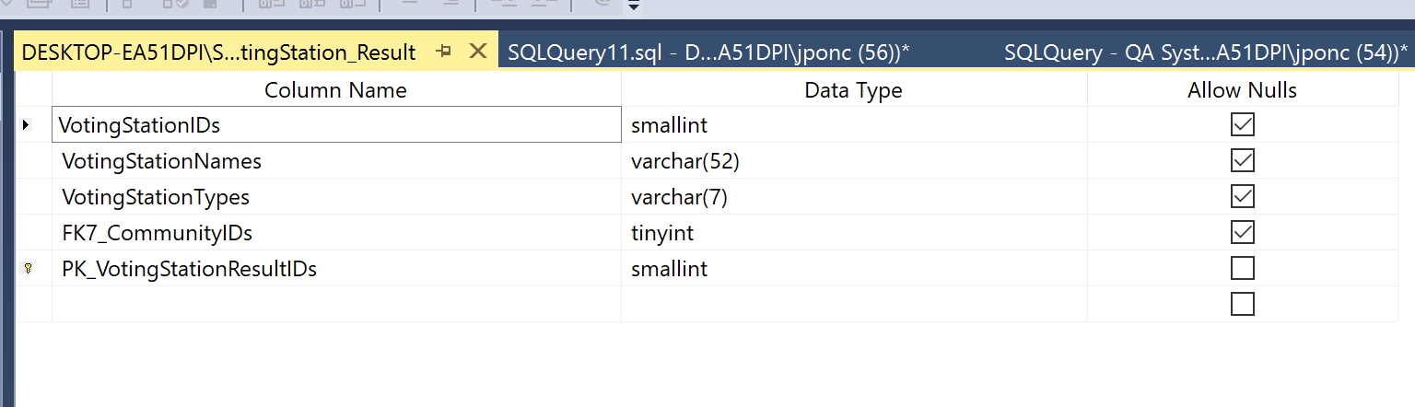

Rows retrieved 292 rows

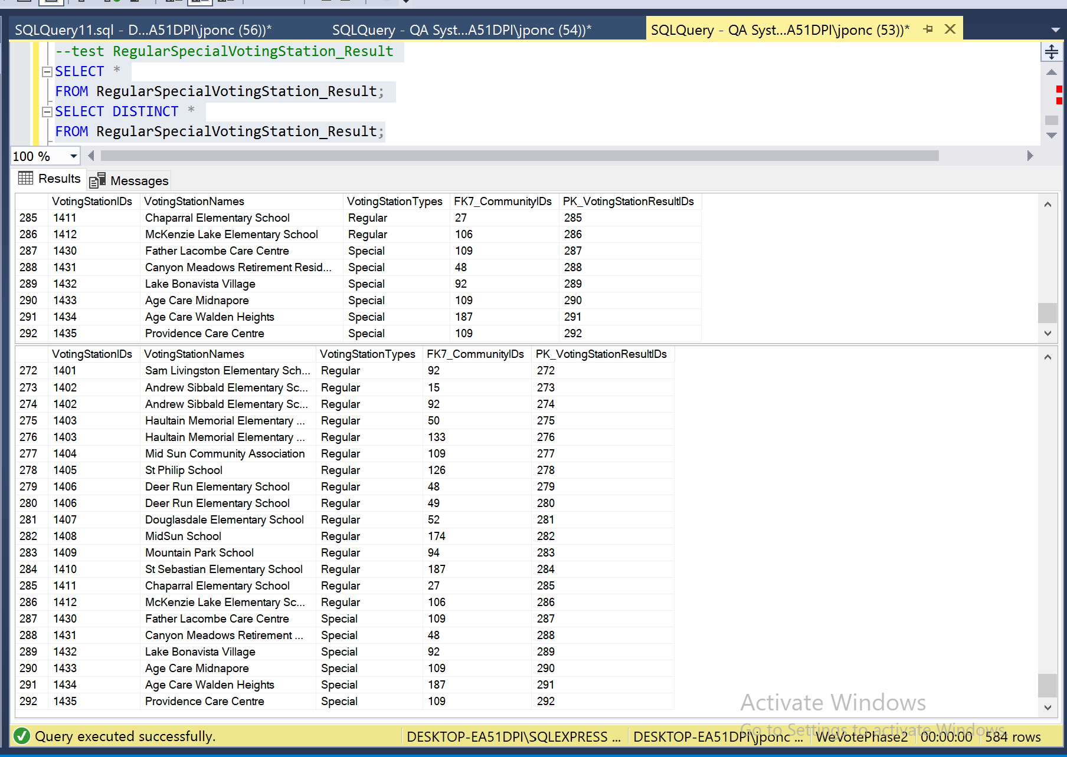

Data Manipulation

Primary Key - Explicit Insert for Identity Column

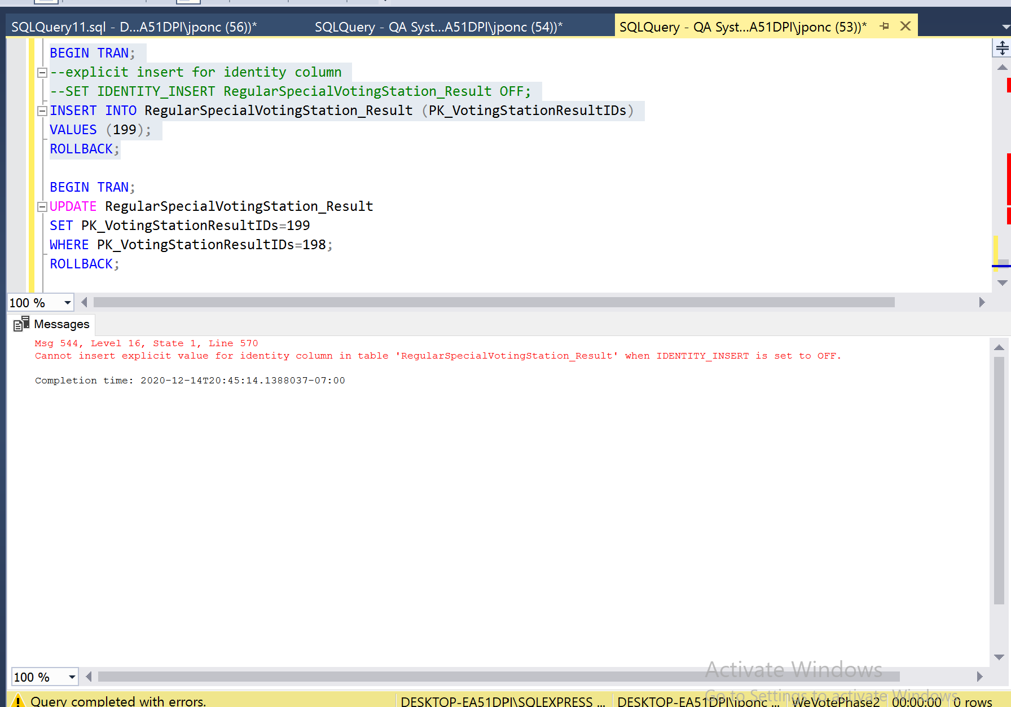

Primary Key – Update

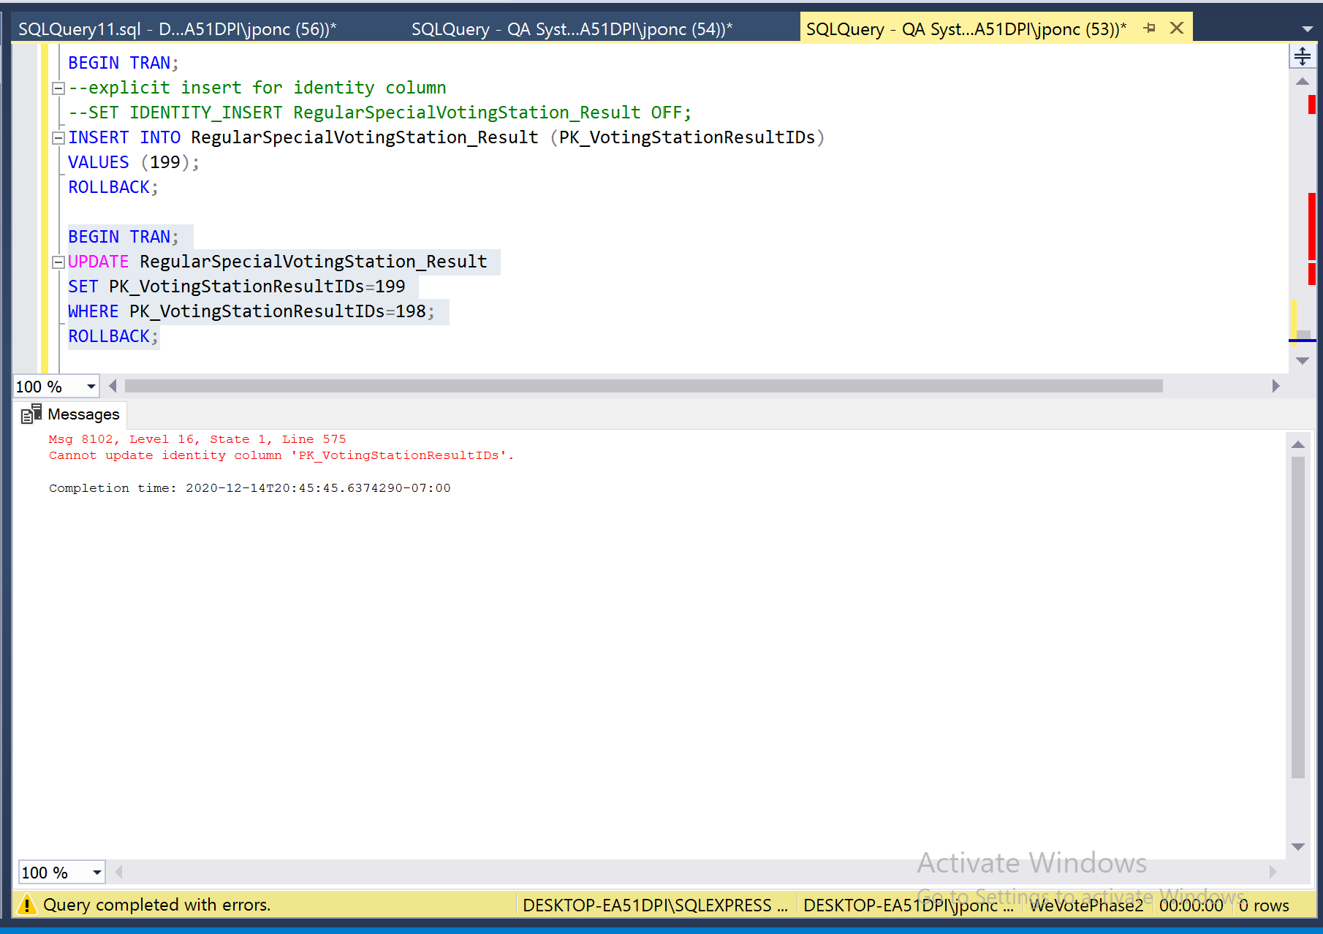

Primary Key related to other table and with Foreign Key

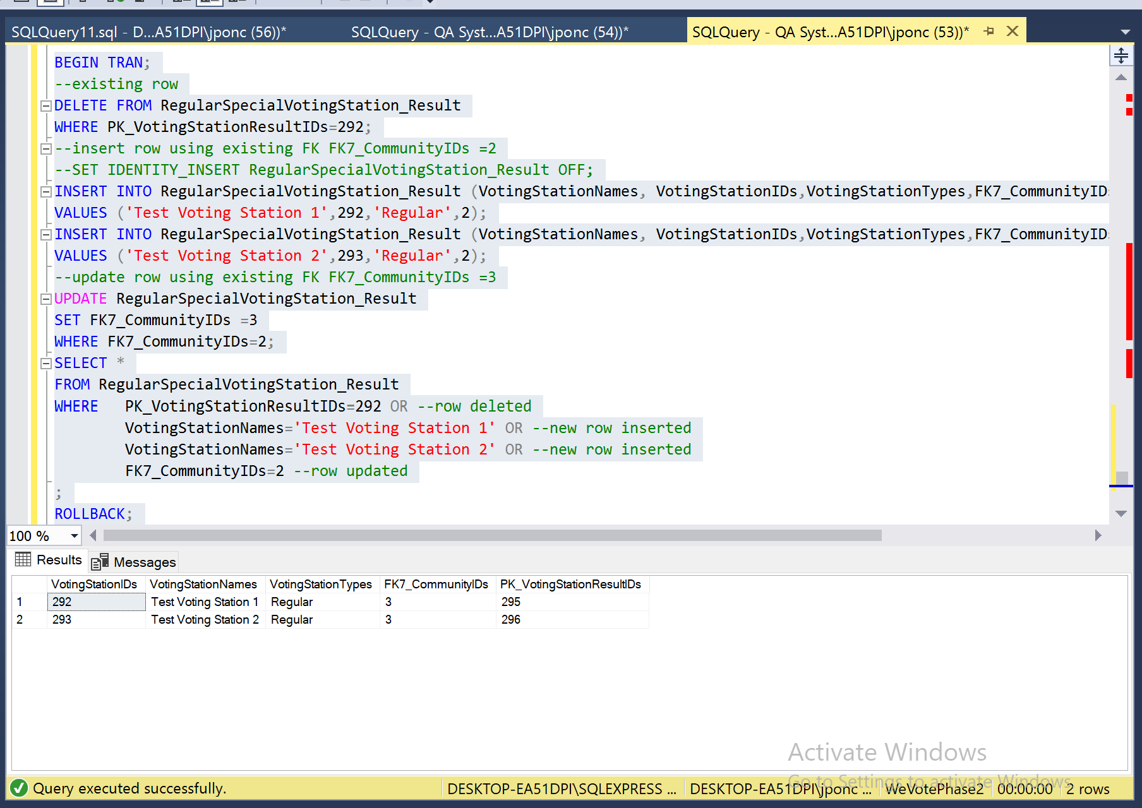

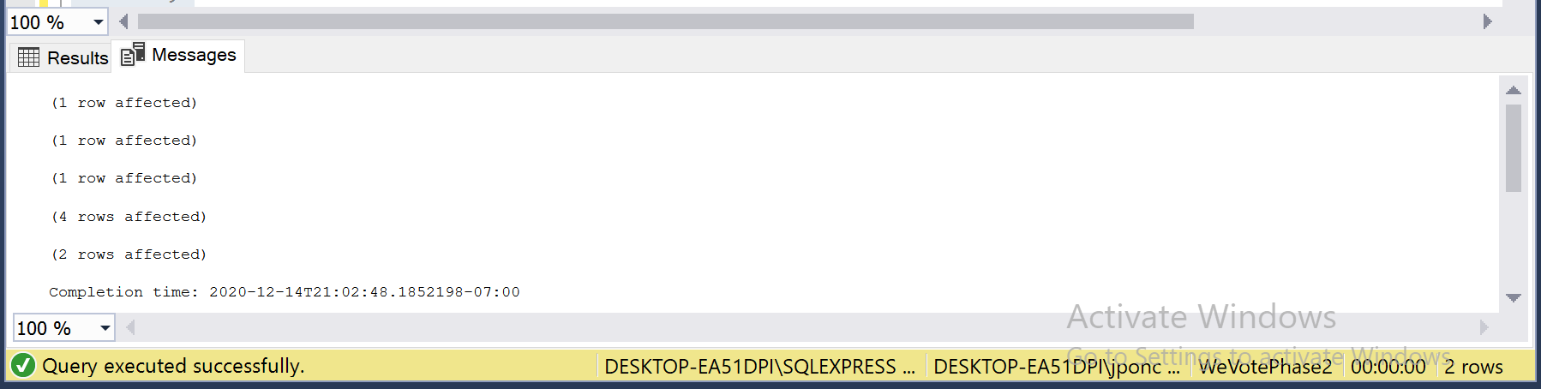

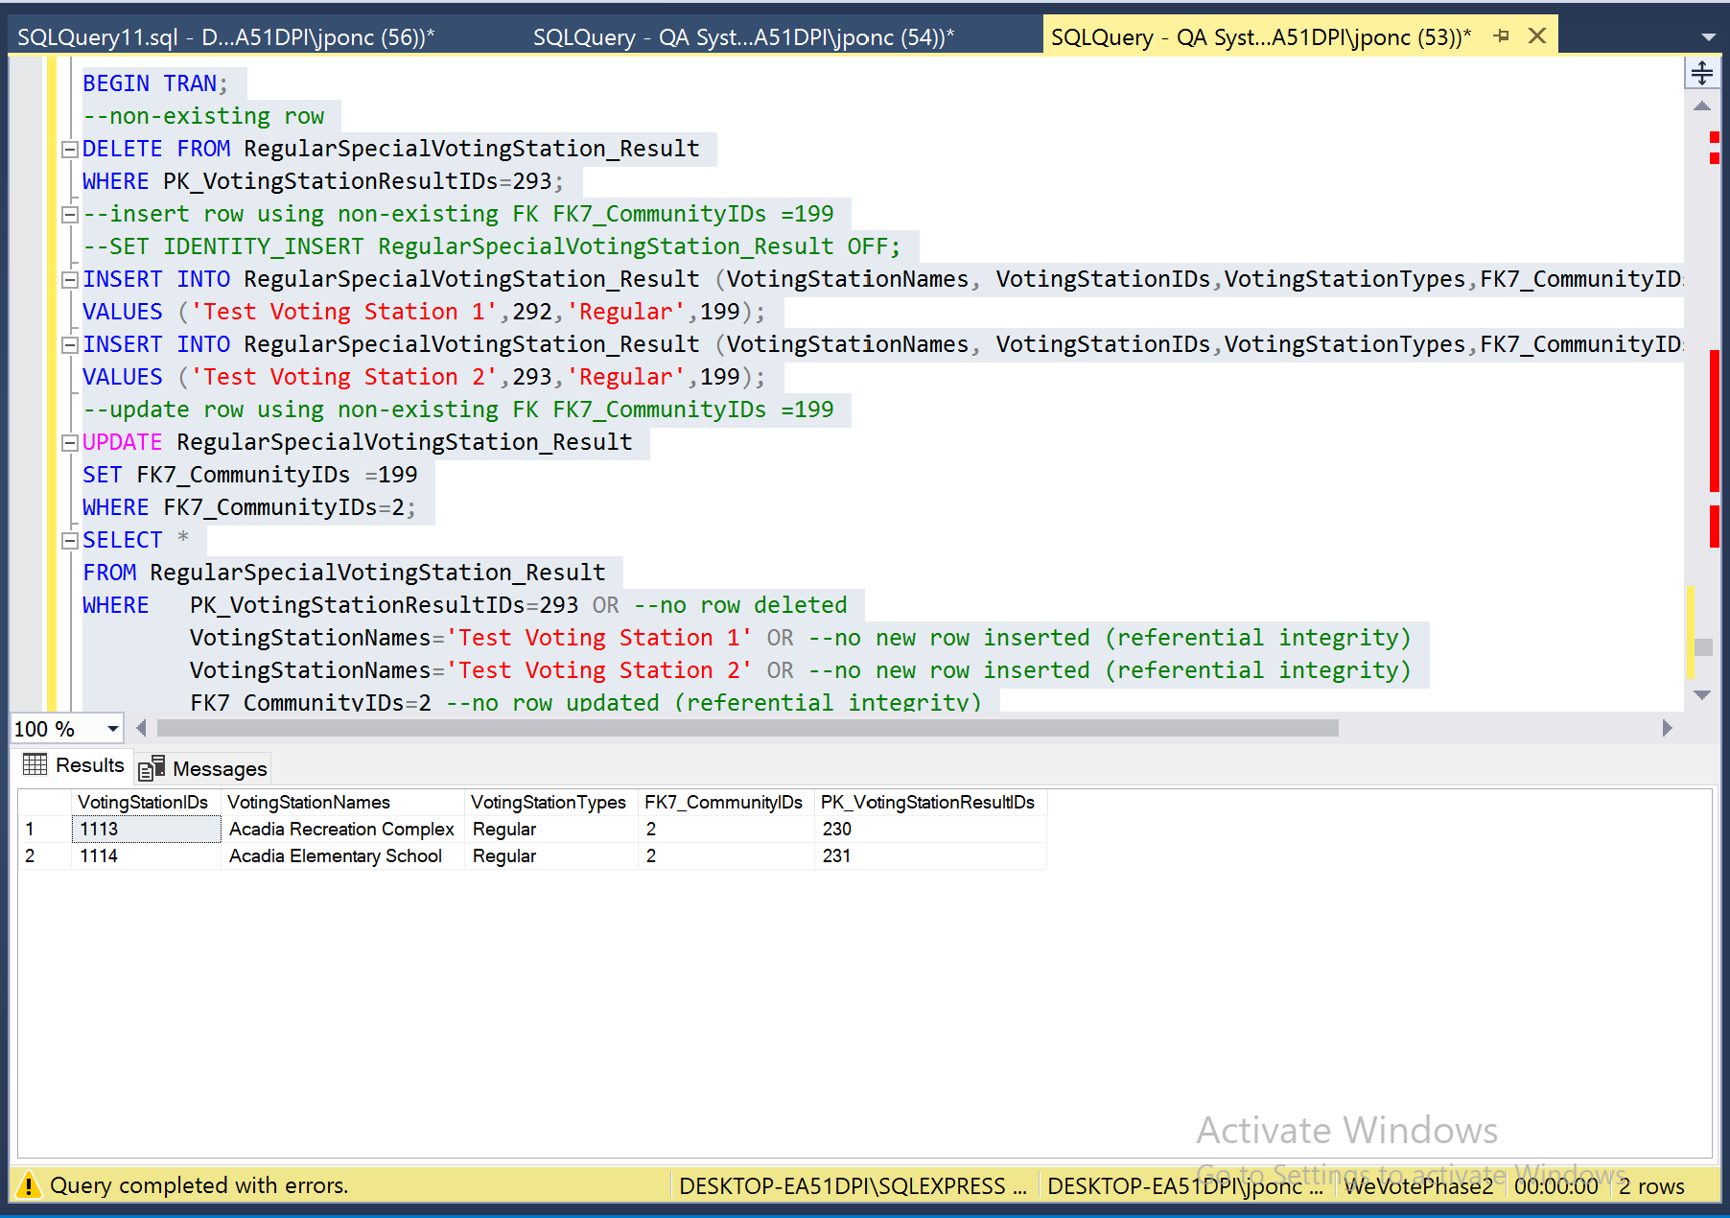

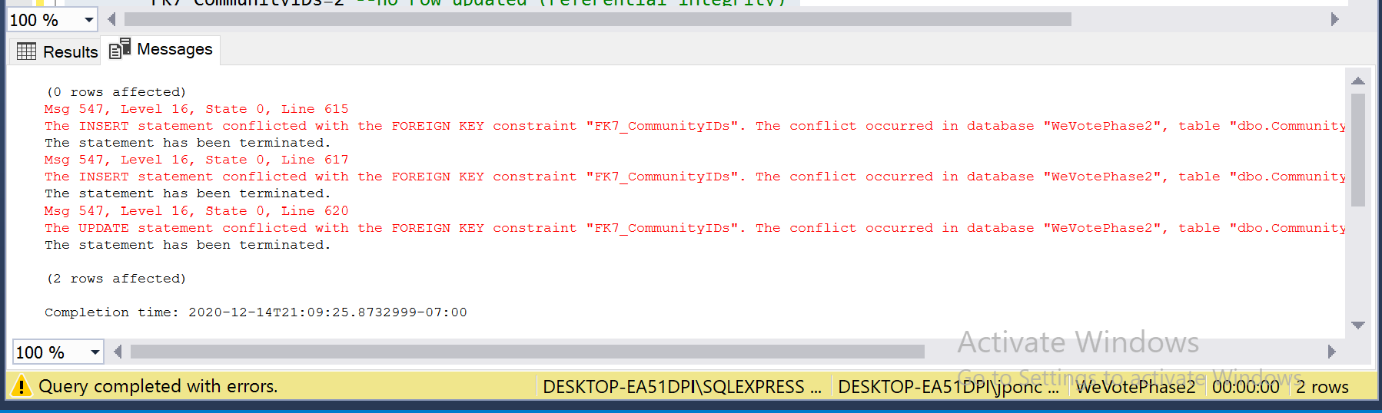

NOT NULL Constraint

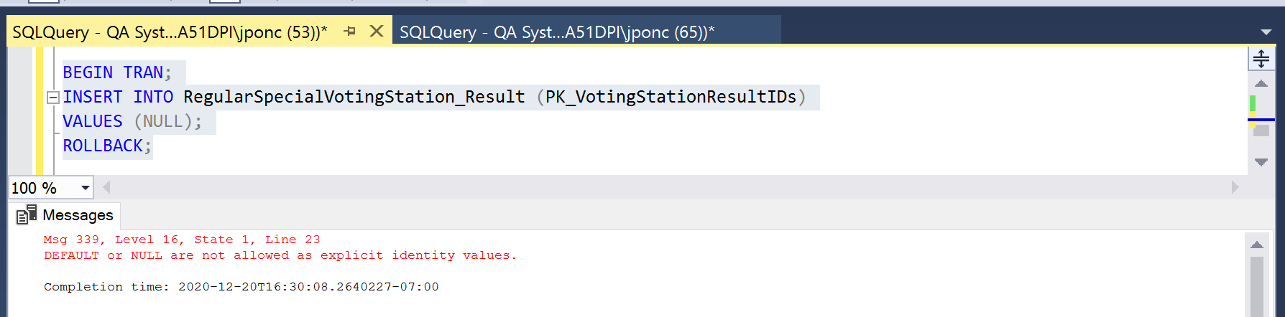

CHECK Constraint

* Review - NO CHECK constraint for VotingStationIDs and VotingStationTypes

